From Tissue Engineering, Saltzman  
Exercise 4.2 (provided by Peter Zandstra)  
In part a and b replace “the uptake” with “the amount of cell-associated”

Cells take up EGF from the extracellular medium by receptor-mediated endocytosis and horseradish peroxidase (HRP) by fluid-phase endocytosis. An example of the cell uptake of EGF and HRP as a function of the concentration in the medium is shown in Figure 4.27.

1. Explain why the uptake of HRP is linear whereas the EGF uptake is hyperbolic.

* Receptor-mediated endocytosis is strictly mediated by receptors on the surface of the cell which can be modeled by the law of mass action equation similar to the equation 4-6 in “Tissue Engineering, Saltzman”. In this process, the limiting factor for the number of proteins to enter the cell is the number of available receptors for the EGF protein to bind to enter the cell by endocytosis. At T0, the time of the beginning of the experimentation, all the receptors are available. As extracellular EGF concentration in the medium is increased, the cell takes up EGF proteins exponentially, this is represented on the EGF protein concentration curve for protein concentration between 0 and 6. Until all the receptors are bound to EGF proteins. Beyond this concentration threshold, around the value 70 on the EGF graph, saturation happens: each additional increment of EGF concentration in the medium results in smaller and smaller increase of cell concentration in EGF, and the curve plateau: the cell in EGF concentration reaches asymptotically its maximum, a value about 180 on the y-axis.
* In fluid-phase endocytosis of HRP: the cell concentration increase in HRP is linearly proportional to the extracellular HRP medium concentration: doubling the amount of concentration results in the doubling the cell concentration in HRP. Unlike the receptor-mediated endocytosis, this endocytosis is not preceded by a specific binding to the plasma membrane or concentration of HRP molecules to specific sites.

1. Explain why the rate of uptake of EGF is much faster than that for HRP.

In receptor-mediated endocytosis, the receptor facilitates the EGF proteins to cross the cell membrane: the EGF proteins bind to receptors concentrated in regions of the cell membrane: the clathrin-coated pits. These pits bud from the membrane to form clathrin-coated vesicles which then fuse with early endosomes which are then sorted for transport to lysosomes.

By opposition, fluid-phase endocytosis (FPE) involves the invagination of the plasma membrane and is limited by the rate of diffusion cross the cell membrane which remain constant for the cells through which the HRP molecules diffuse.

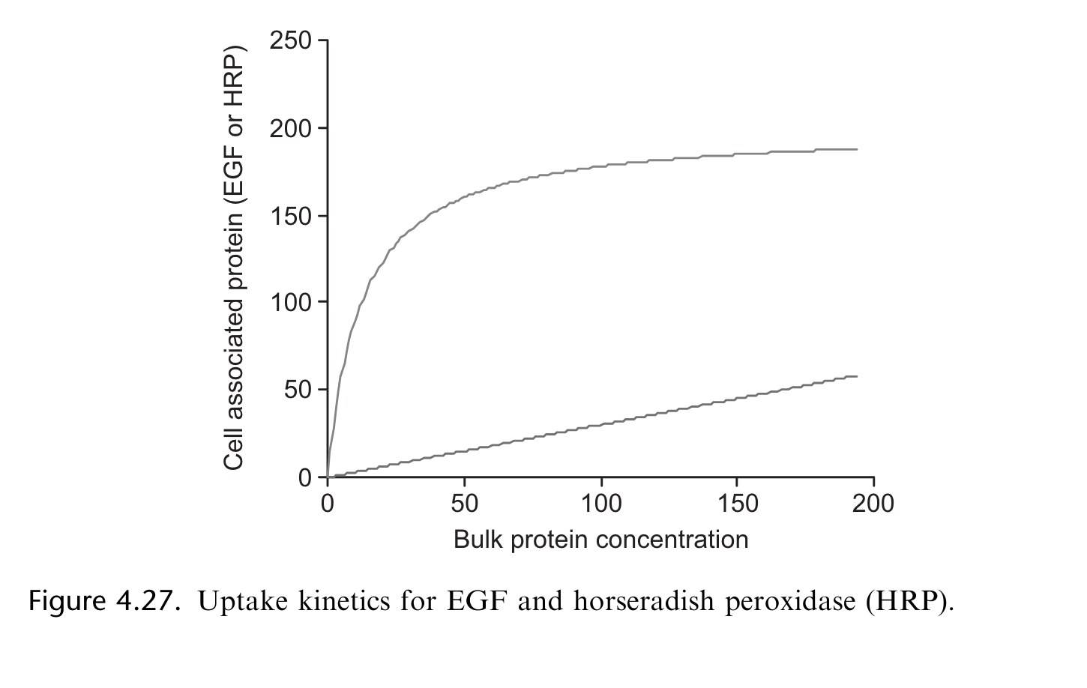

2. In order to model the protein dynamics of a ligand binding to a receptor you need to both write appropriate equations and know appropriate parameter values. In this problem you will investigate a 2- state receptor-ligand network. In this network the receptor is either active (called A) or inactive (called B). As we discussed earlier this semester – regulation occurs on many levels in the body and changing the activity state of a receptor is one level of regulation that allows for quick changes to the cell behavior. Instead of turning on a gene, transcribing, translating, folding and translocating – the cell can keep all of the receptors made in an inactive state and simply activate them when needed.

1. Please write ODEs to describe this system (following the Laws of Mass action). There should be 5 equations, one for each species present in this system (for example d[A]/dt)

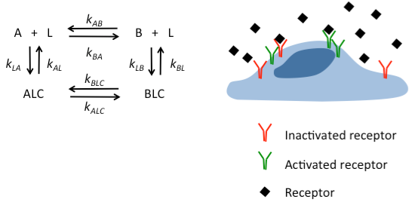

Applying the laws of mass action, we have:

d[A]/dt = k***AL*** [ALC] + k***AB*** [B] [L] – k***LA*** [A] [L] – k***BA*** [A] [L]

d[A]/dt = k***AL*** [ALC] + k***AB*** [B] [L] – (k***LA*** + k***BA***) [A] [L] [eq. 1]

Similarly

d[B]/dt = k***BL*** [BLC] + k***BA*** [A] [L] – (k***LB*** + k***AB***) [B] [L] [eq. 2]

d[ALC]/dt = k***LA*** [A][L] + k***BLC*** [BLC] – (k***AL*** + k***ALC***) [ALC] [eq. 3]

d[BLC]/dt = k***LB*** [B][L] + k***ALC*** [ALC] – (k***BL*** + k***BLC***) [BLC] [eq. 4]

d[L]/dt = k***AL*** [ALC] + k***BL*** [BLC] – k***LA*** [A] [L] – k***LB*** [B] [L] [eq. 5]

1. Please describe methods you could use to experimentally measure the necessary parameters including rate constants and species concentration.

We can set up a study where we know how to downregulate certain proteins or use inhibitors to activate or deactivate all the receptors of type [R].

This allows us to have two distinct experiments:

1. A + L ⬄ [ALC] with dissociation constant kAd = k***AL /*** k***LA***
2. B + L ⬄ [BLC] with dissociation constant kBd = k***BL /*** k***LB***

For the first experiment: A + L ⬄ [ALC]

We assume that:

1. The number of ligands is constant through the entire experiment: L0
2. Total number of receptors is constant: RAT = RA + [ALC]

From the laws of Mass Action, we have: [ALC]eq = kAT [L0] / ([L0] + kAd)

Rewriting this last equation: [ALC]eq/([L0] = -1/ kAd [ALC]eq + kAT / kAd

1. A Scatchard analysis can then be performed and the plot of the data: ratio of bound ligand to free ligand concentration is a line with slope (-1/ kAd) which allows us to determine kAd. and similarly, kBd using the experiment B + L ⬄ [BLC] with all the receptors deactivated.

Note that from kAd = k***AL /*** k***LA*** knowing one of the constant rates; for example, k***AL*** yields the other: *k****LA***.

1. Next, we plot the change in concentration [ALC] vs. time; and we fit a hyperbolic curve to the data.
2. We substitute k***AL=***  kAd *  k*LA*in the equation:

[ALC] = [ALC]eq (1 – exp(- (k***AL*** + k***LA***) * t)

and solve for k***LA*** using the hyperbolic curve we just fit to the data. We then obtain k***AL*** from k***LA***using k***AL=***  kAd *  k*LA*.

1. We proceed to the same data analysis to determine k***BL*** and k***LB***.

We induce in the ligand [L] a conformational change so it cannot bind to a receptor active ([A]) or inactive ([B]) and we proceed to this experiment:

A + L ⬄ B + L

We assume the number of ligands is constant through the experiment. Starting at T0, all the receptors are in the deactivated state. By increasing progressively, the number of active receptors and plotting the curve [A] vs. [B] we can evaluate the constant rate of transformation from inactive to active k***AB***which is the slope of the curve. We repeat the experiment but this time starting at T0 with all the receptors being active and increasing over time the number of inactive receptors to determine k***BA***.

The next experiment is similar to the previous experiment:

* Starting with all the receptors inactive we increase the number of ligand so all the ligands are bound: [BLC] and we gradually active them so some of the complexes become [ALC]. Collecting the data and plotting it over time help us to determine the constant rate k***BLC***.
* Proceeding from T0 with all the ligands bound to active receptors and decreasing the number of active receptors by deactivate them over time; plotting [BLC] vs. [ALC] gives us the constant rate k***ALC***.

After the determination of the constants: k***AL***, k***LA*** , k***BL***, k***LB*** , k***AB*** , k***BA*** , k***ALC*** andk***BLC*** we can then resolve our system of ODEs.

To validate the solutions obtained from solving the ODEs, we can plot the concentration of species [A],[B],[ALC],[BLC], and [L] (if we don’t consider the concentration of ligand constant though the experiments) over time during our previous experiments; plot also the curves obtained mathematically (solutions of the ODEs) and see how accurately these curves fit the data.